How to renew your Ga Compact license
- After you complete the IMLCC process and pay the fee you will then go to the Ga License portal at https://gateway.medicalboard.georgia.gov/ and register for an account if you do not have one:
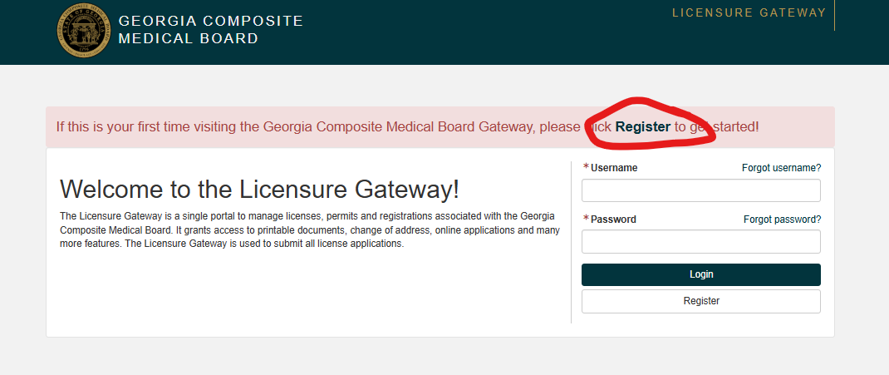
- Depending on when you completed you received your compact license you will either choose “physician or Physician-Compact”. Ones approved prior to July 2025 will most likely be “physician”.
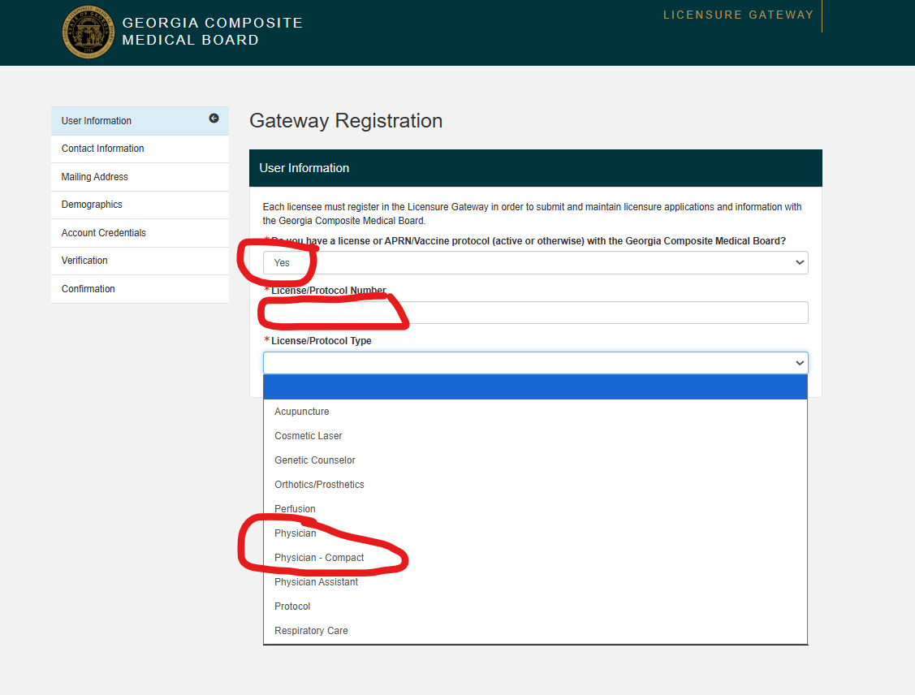
- Once registered, sign in with your new username and password. You will see the page below. Click on the green “Physician” tab to move to the next page.
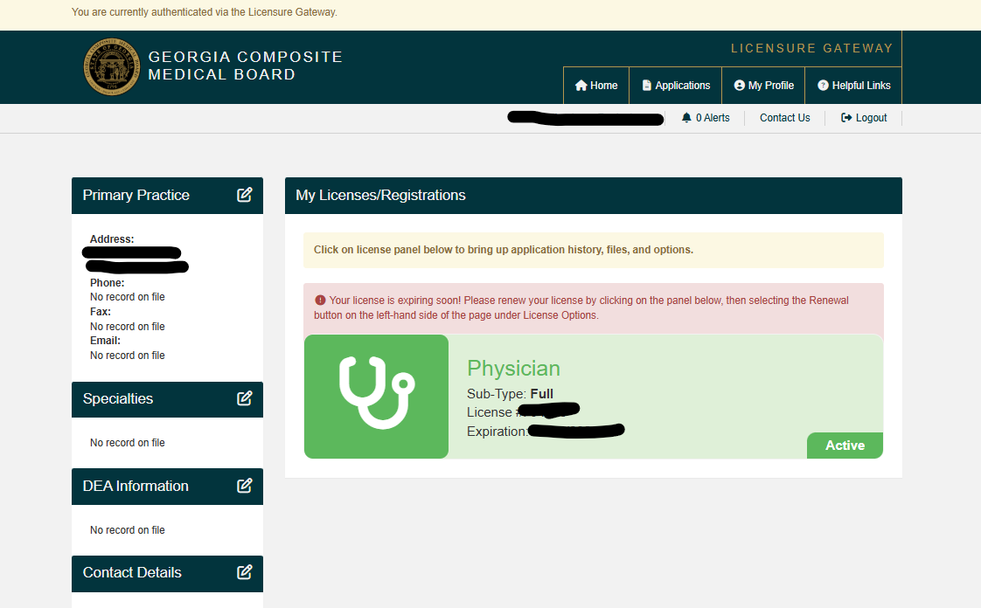
- On the next page click on the orange “renewal” button. Complete the application and submit it. DO NOT pay again, GCMB staff will apply your IMLCC payment to the application and approve it.
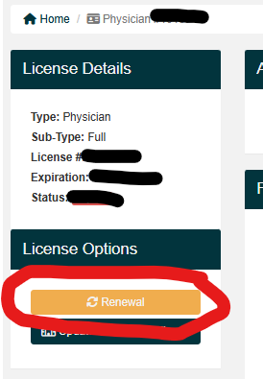
Until we get an API with IMLCC for renewals and they automatically move to our system, we will utilize this method which is the easiest way to renew your Georgia license.

